Royal Greeting Cards
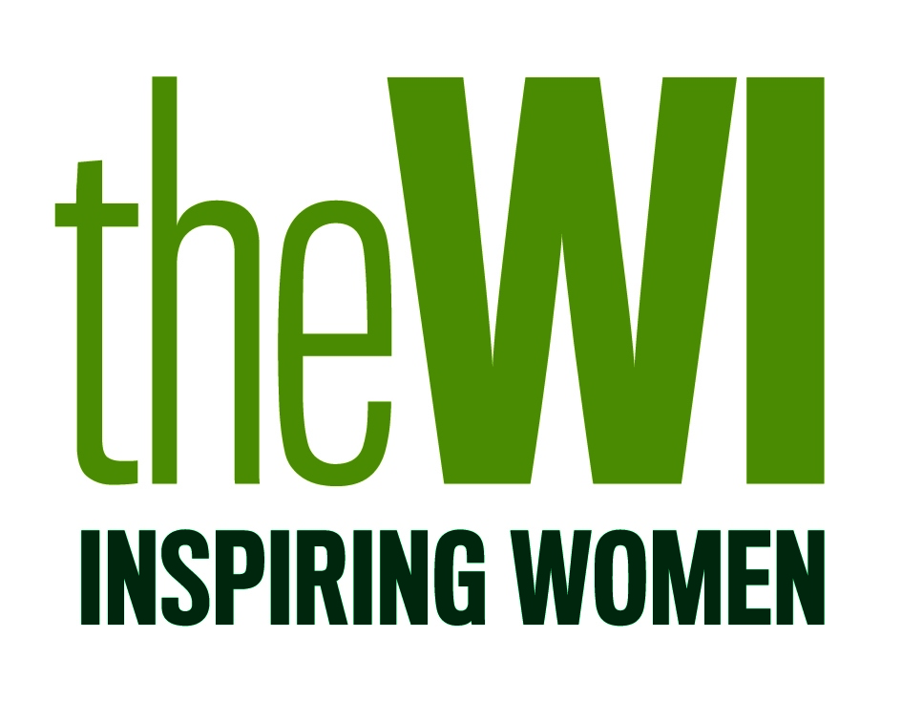
Guidelines for Makers

- The craftsperson/maker must be a WI member.

- The Chair of Activities Committee, with the support and guidance of an external professional, if necessary, will select the final card which will be sent on behalf of the WI.

- Commercial items, such as toppers, stickers or wording, should not be used. Branding or manufacture logo’s must not be visible.

- The final card dimensions should measure no less than 148 x 210mm (A5) and no more than 210 x 297mm (A4).

- If mounting the piece of work onto card, before being sent to the NFWI, inside text must read ‘WI members send their warmest good wishes to you on this very special day’. If the maker choses to not mount their work, this will be done by the NFWI and the text entered on their behalf.

- The maker must provide a short written statement explaining the theory behind their finished piece of work plus a brief bio of themselves. This piece must be written and presented to a high standard worthy of accompanying the finished card.

- The finished piece of work must be completed by 1 March 2021 and sent by Royal Mail, Recorded Deliver to the the NFWI, Denman, Marcham, Abingdon, Oxon, OX13 6NW. Unfortunately, it is not possible to arrange for the card to be delivered by hand. Please include the name and contact details of the maker, including address, email, WI and federation – this must be written separately and not within the supporting statement.

- The chosen finished card will be sent to the NFWI Head Office, London to be signed by the NFWI Chair, and photographed before being sent to Buckingham Palace. The card will be sent along with the written piece detailing the maker (refer to point 5).

- The maker must ensure the card is wrapped and packaged securely in a box. The box, containing the card, will be presented to the palace, therefore the maker must ensure that the box represents the style and standard of the card.

- The NFWI will reimburse the maker for the cost of materials and postage.

- The NFWI reserves the right to publish images of the finished card, along with the written statement, on WI social media channels, My WI and in WI Life.

- The finished card will be sent to the Palace on behalf of all WI members, for this reason, the NFWI will take ownership and responsibility of the card.

- Once the card has been sent to the Palace, the maker nor the NFWI will be able to ask for the card to be returned.

