JUDY THEOBALD BOOKS

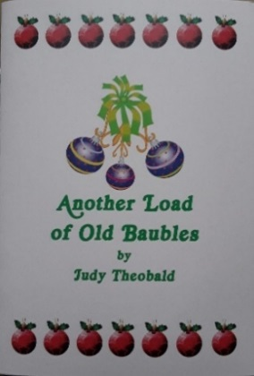
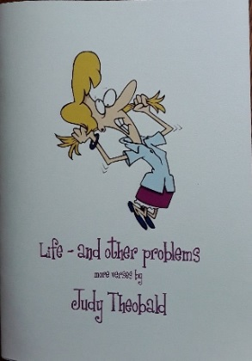
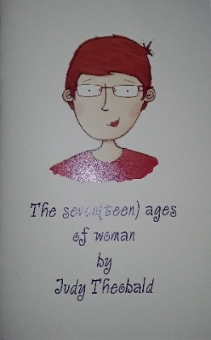
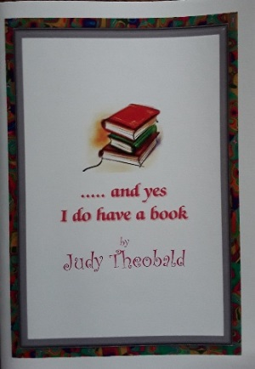

And yes, I do have a book,
The Seven(teen) Ages of Woman,
Life and other problems
and the Christmas book, Another load of old Baubles.
Packing and postage: Orders for one book: £1.50
Orders for two to five books: £2.50
Title |  | Price each | Quantity | Total £
And yes, I do have a book |  | £3.00
Another load of old baubles |  | £3.00
The Seven(teen) Ages of Woman |  | £3.00
Life, and other problems |  | £3.00
Packing and postage (please see above)
TOTAL ORDER PRICE
Name
Address
Town
Postcode
WI
Where possible please send your payment by online banking to:
Account: Lincolnshire South Federation of WIs
Bank: Lloyds Bank
Sort code: 309089
Account no: 43337760
Reference: Judy Books/****your name****

